Project 4c - Keyword Extraction

Problem
Natural Language Processing (NLP) is an important area of computation that attempts to use computer programs to glean information from text. At its simplest, it could be just a determination of which pronouns are used in a sentence, and at its most complex it can involve advanced artificial intelligence. One problem NLP is used to solve is keyword extraction. A selection of text is provided to the program and the program determines which words are the important ones. You can imagine that this could be useful in many ways.
One well-established approach to keyword extraction is term frequency–inverse document frequency (Tf-idf). The name of the approach is fairly intimidating, but the actual approach is fairly straightforward. The idea is to figure out 1) how often a word is used in the text (term frequency) and compare it to 2) how often the word is commonly used in the text (document frequency). Naturally, there is a TF-idf formula used to calculate this value for each word in a document. We will use a variation of this formula for this project.

Objectives
- Identify the keywords in a text sample
- Clean up the sample text by removing distracting characters:
  - . , " ' ? ! “ \t \r \n , ” :
- Use a dictionary variable to create a frequency histogram
- List the top words contained in the sample with the most important words listed before the least important words as defined by our version of the Tf-idf metric
- Visualize the distribution

Some Guidance
Create a program that calculates our keyword metric, reports the most important words and allows the user to specify:
- the word frequency file name - ask for a file name but have a default of KFfreq.csv which is the file to be used if the user doesn’t specify a file
- # of key words to report - the number of top key words to report
- name of a text file to process - the name of a text file to process using our program but if the user leaves this blank, then the following question is asked
- text to be processed - only if a file name is not provided for som text to process, then the user can simply paste some text in response to this question and that text will be processed

The general steps for this program are:
- get the values from the user
- acquire the text from a file, if the user didn’t provide the text
- clean up the text by removing the undesired characters
- acquire word frequencies from the word general frequency file
- create a score and associate it with each word (words without a general frequency available should be given a frequency of 1)
- create a printed report of the top words
- visualize the results with a plot
I will provide you with a function
reportHisto(histogram, TopN, title="title", xLabel = 'xLabel') that you can use to create plots. An example of calling this function is: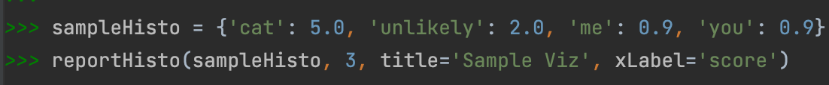
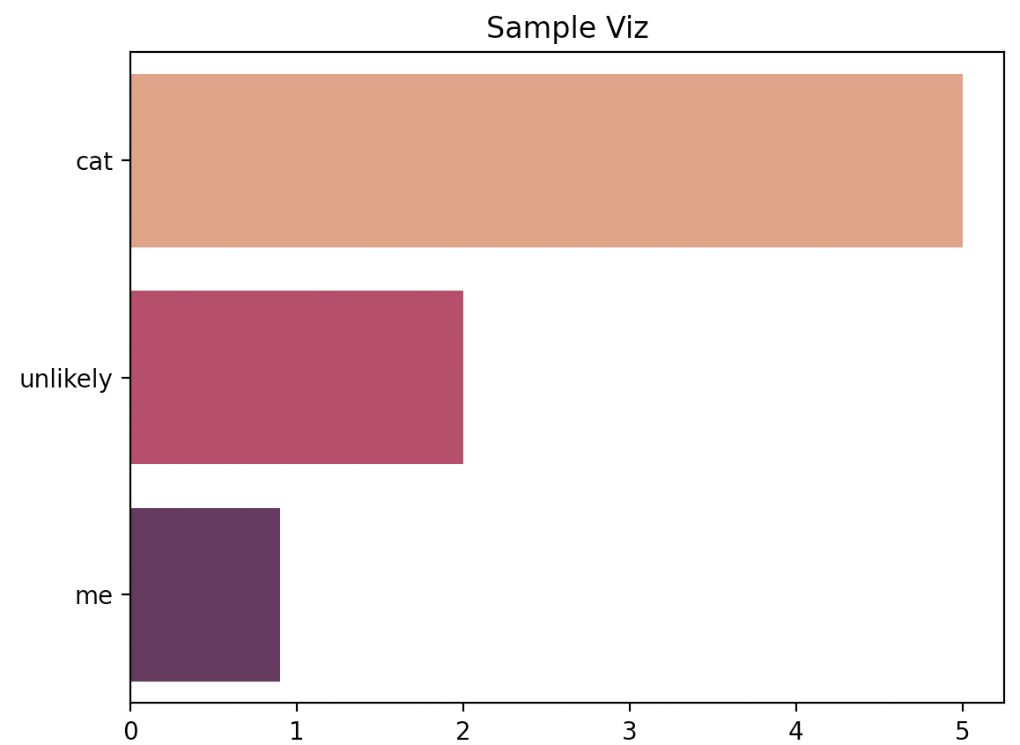

Our version of the TF-idf equation
We will use an approximation of the TF-idf equation for our program.

For any word there is:
$WordDocFreq$ - how many times that the word is used in the text sample provided
$WordGeneralFreq$ - how many times the word is generally used in a big general sample.

For any text sample there is:
$MaxFreq$ - a highest frequency for a word

The equation we will use is:
$TFIDF = 0.5 + 0.5 (WordDocFreq/MaxFreq) log(500/(1+WordGeneralFreq))$

Useful links:
TF-IDF from scratch in python on a real-world dataset.
TF IDF | TFIDF Python Example
tif-idf on wikipedia

Here are two examples of the program being run with text outputs and complete plot images.
